NAME: VENKATRAMAMOORTHY.G
- Render a list of products using `.map()` with stable `key` props.
CODE:
const products = [
{ id: 1, name: "Laptop" },
{ id: 2, name: "Phone" },
{ id: 3, name: "Keyboard" },
];

function ProductList() {
return (
<ul>
{products.map((product) => (
<li key={product.id}>
{product.name}
</li>
))}
</ul>
);
}
export default ProductList
OUTPUT:
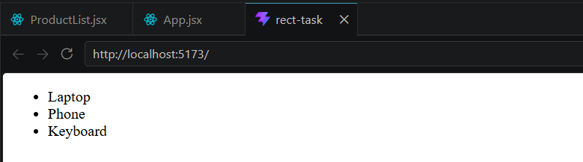
- Show 'No products available' when the list is empty using a conditional (ternary/&&).
CODE:
const products = [];

function ProductEmpty() {
return (
<div>
{products.length > 0 ? (
<ul>
{products.map((product) => (
<li key={product.id}>{product.name}</li>
))}
</ul>
) : (
<p>No products available</p>
)}
</div>
);
}
export default ProductEmpty
OUTPUT:
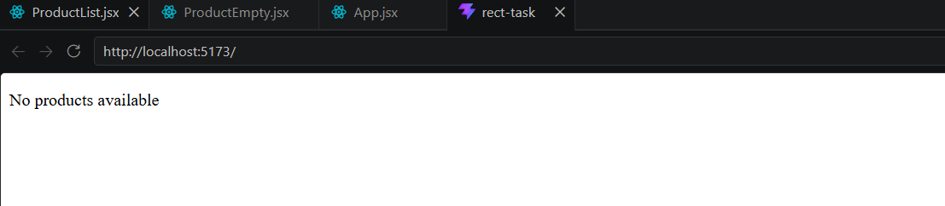
- Implement a filter input that filters the rendered list by product name.
CODE:
import React, { useState } from "react";

const products = [
{ id: 1, name: "Laptop" },
{ id: 2, name: "Phone" },
{ id: 3, name: "Keyboard" },
];

function ProductFilter() {
const [search, setSearch] = useState("");

const filteredProducts = products.filter((product) =>
product.name.toLowerCase().includes(search.toLowerCase())
);

return (
<div>
<input
type="text"
value={search}
onChange={(e) => setSearch(e.target.value)}
/>
<ul>
{filteredProducts.map((product) => (
<li key={product.id}>{product.name}</li>
))}
</ul>
</div>
);
}
export default ProductFilter
OUTPUT:
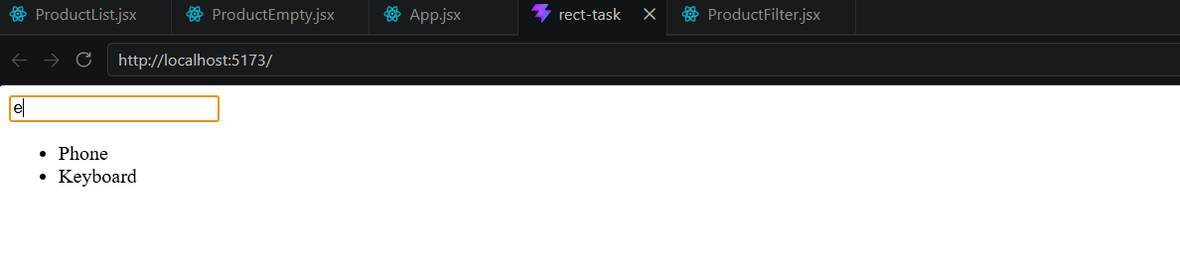
- Highlight an item on hover using conditional class application.
CODE:
import React, { useState } from "react";
import "./styles.css";

const products = [
{ id: 1, name: "Laptop" },
{ id: 2, name: "Phone" },
{ id: 3, name: "Keyboard" },
];

function HoverHighlight() {
const [hoveredId, setHoveredId] = useState(null);

return (
<ul>
{products.map((product) => (
<li
key={product.id}
className={hoveredId === product.id ? "highlight" : ""}
onMouseEnter={() => setHoveredId(product.id)}
onMouseLeave={() => setHoveredId(null)}
>
{product.name}
</li>
))}
</ul>
);
}
export default HoverHighlight;
OUTPUT:
